Chinese Quiz
1) When greeting someone in the morning, the most appropriate greeting is:
- Nǐ hăo.
- Wăn ān
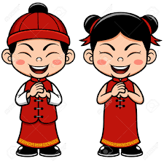
- Zăo shàng hăo.
- Wăn shàng hăo.
2) When thanking someone in Chinese you should say:
- Hăo hăo.
- Xiè xie.
- Zaì zai.
- Duì dui.
3) What word is missing from this sentence? Nǐ jiào ___________ míngzi?
- Shénme
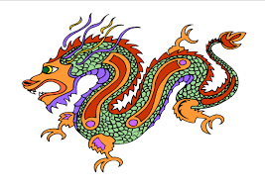
- Shimme
- Suì
- Shàng
4) What information is this sentence asking for: Nǐ duō dà?
a) your name
b) your age
c) your phone number
d) your birth date

5) What information is this sentence asking for: Nǐ de dìanhuà hàomă shì shénme?
a) your name
b) your age
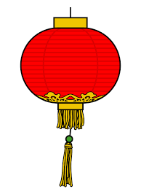
c) your phone number
d) your birth date

6) If asked for your age, what would be the most appropriate answer?

- Wǒ èr shí suì.
- Wǒ shí èr suì.
- Wǒ yī shí suì.
- Wǒ shí san suì.

P.T.O.

7) The most suitable reply to the question Nǐ hăo ma? is:
a) Hăo bù hăo.
b) Nǐ hăo.
c) Wǒ hĕn hăo.
d) Nǐmen hăo.

8) The following question Jīntiān shì jǐyuè jǐ haò? is asking about:
a) your birthday
b) the weather
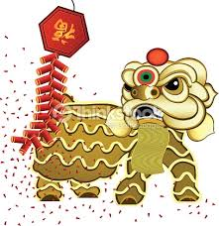
c) your age

d) the date today

Character recognition

- Which character means ‘I, me’?
- 你 b) 握 c) 我 d) 呢

- Which character means ‘called’?
  - 我 b) 好 c) 你 d) 叫

- Which character is in the greeting Nǐ hăo?
  - 好 b) 吗 c) 奴 d) 倪
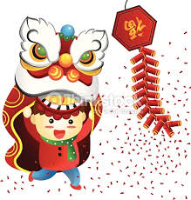

- Which character would you see in the date?
  - 月 b) 有 c) 钥 d）腥

- Which character means ‘you’?
  - 我 b) 你 c) 倪 d) 握

- Which two characters mean ‘April’?
  - 八月 b) 三月 c) 九月 d) 四月

- Which two characters mean ‘September’?
  - 九月 b) 十月 d) 七月 d) 六月

- Below are the characters for numbers 1 – 10. Write them in the correct order.
九 三 四 十 五 八 一 六 二 七

____ ____ ____ ____ ____ ____ ____ ____ ____ ____

